[NLP & IR]
Project : LSI model
20212816 | 박철오

1. Introduction
2. Background
2.1 Vector-space model
2.2 Latent Semantic Indexing
2.3 From VSM -> LSI
3. Implementation of LSISearcher class
4. Experimental setup
5 Results
5.1 Quantitative
5.2 Qualitative
6. Conclusion & Future Work

1. Introduction
Classic IR engines rank documents with tf-idf cosine in a high-dimensional vector-space model. That approach breaks whenever relevant documents use synonyms or when one word has several meanings. Latent Semantic Indexing tackles this by applying truncated SVD to the term-document matrix, collapsing thousands of word axes into a few “concept” dimensions and thus grouping semantically similar texts.
In this project, I implemented LSI-based searcher, then compared ranking quality and computational costs with VSM on the same corpus to highlight exactly what is gained—and lost—by adding the latent layer.

2. Background
2.1 Vector-space model
- Bag-of-words representation
- Benefits : simple, fast and interpretable
- Limitations : lexical gap, sparsity in matrix; high dimensionality
2.2 Latent Semantic Indexing
- Sentence definition
- Intuition : rotation + compression -> “concept” axis
$A=UΣV^{T}$,
$U$ : captures term-term co-occurrence patterns. It is obtained from eigenvectors of $AA^{T}$; each column represents latent “term topic.
$Σ$ : The strength of connection between word-cluster and topic.
$V$ : captures doc-doc similarity. Tells how alike two documents are in terms of their word distribution. . It is obtained from eigenvectors of $AA^{T}$.
- Benefits : synonym linking, noise reduction, smaller vectors
- Costs : less interpretable, heavy SVD computation
2.3 From VSM -> LSI
- One axis per term -> keeps only k latent axes
- Each dimension : word -> concept
- Similarity metric : term space cosine -> latent space cosine
- Handling synonymy : fails -> similar terms cluster together
- Handling polysemy : one word to one axis -> different senses distinguished

3. Implementation of LSISearcher class
i) Building original term-document space :

As for VSM, build tf-idf table. Here, I used $idf=\log\left(\frac{N}{df+1}\right)$ to down-weight very rare terms.
ii) SVD and reduction :
I used TruncatedSVD supported by sci-kit learn. The decomposition $A=UΣV^{T}$ took place here. The document vectors in latent space was discovered here, given by ${\left(ΣV^{T}\right)}^{T}$ (Transposed once again to make it document-topic order)
iii) query transformation :
This method is responsible for projecting raw query onto latent space. With the precomputed projection matrix, given by $Σ^{-1}U^{T}$, query $q$ gets projected onto latent topic space.
iv) search method :
Here, the cosine similarities between “query on latent topic space” and “document on latent topic space” are computed here by doing dot products, then the documents get ranked accordingly.

4. Experimental setup
Corpus : 55 files at https://github.com/ppco915/NLP-IR/tree/main/textual_dataset
Queries : 5 short keyword queries with k fixed to 20
Metrics : precision@5 (small since total # document is 55)
k values : 10, 20, 30, 40
execution time : model setup time, search operation time

5 Results
5.1 Quantitative result & summary
Query : “spaceX conducting new engine tests”
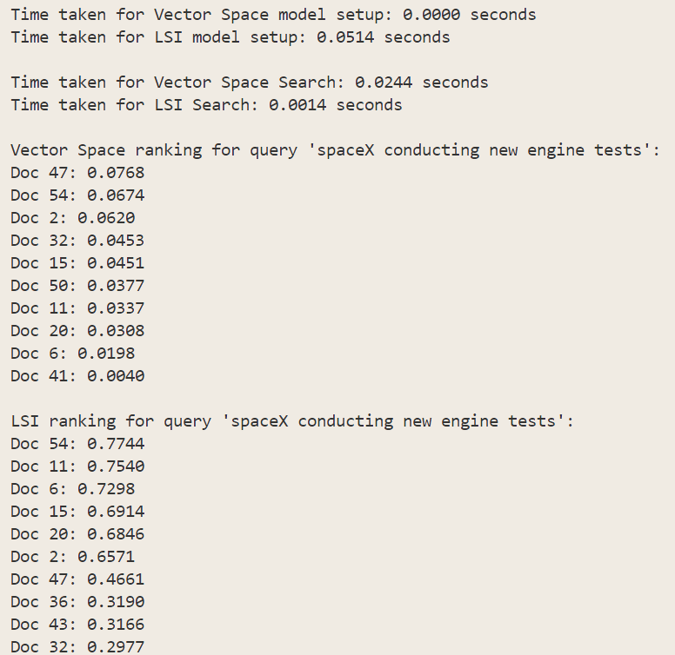
VSM precision : 3/5
LSI precision : 3/5
Though low in my satisfaction level, LSI closely captured both company name “spaceX” along with content about launching, while VSM gave the wrong result as #1 result.
Query : “websites or browsers features”
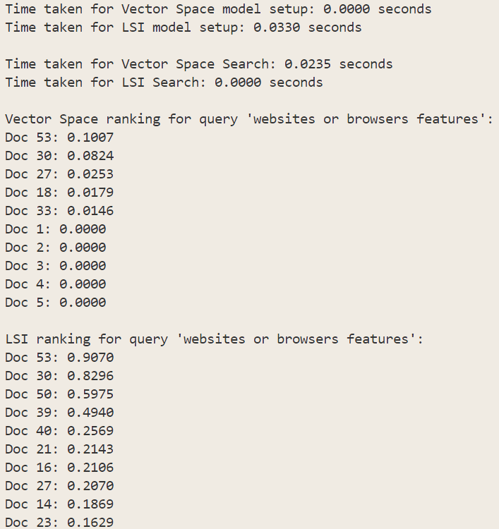
VSM precision : 2/5
LSI precision : 4/5
Both LSI and VSM was able to fetch apparently relevant documents, however, the gap followed immediately. VSM gave the irrelevant documents for the rest three, while LSI correctly retrieved two other documents, and one not perfectly aligning but still adhering to topic of IT.

Query : “telescope” & “telescopes”
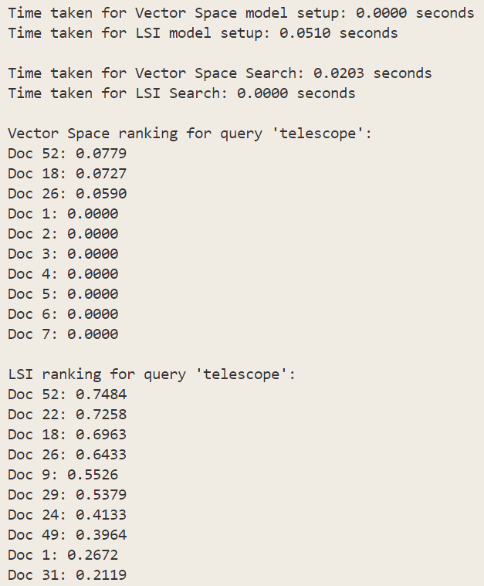
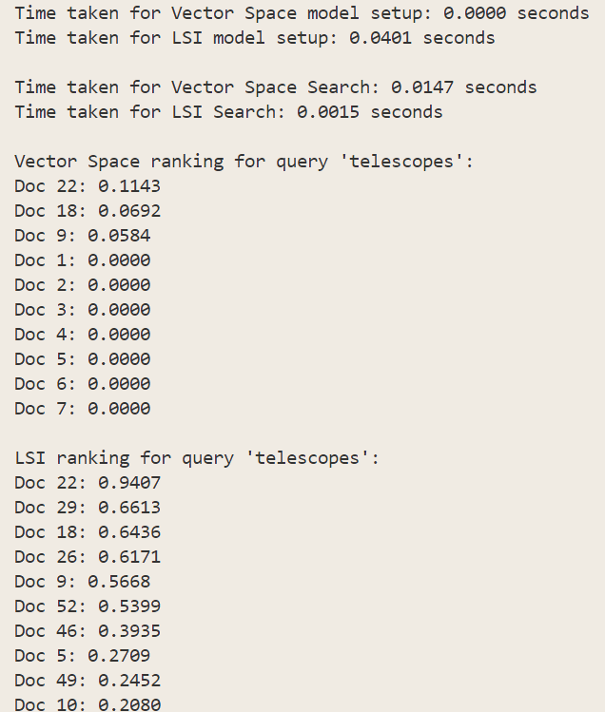
A singular to plural difference in single-word query produced 2/3 difference in VSM, while LSI almost produced the same result with slight change in ranks. At least, the three documents VSM gave were all relevant to the query.
VSM precision : 3/5, only three were retrieved though.
LSI precision : 5/5

Query : “btc”
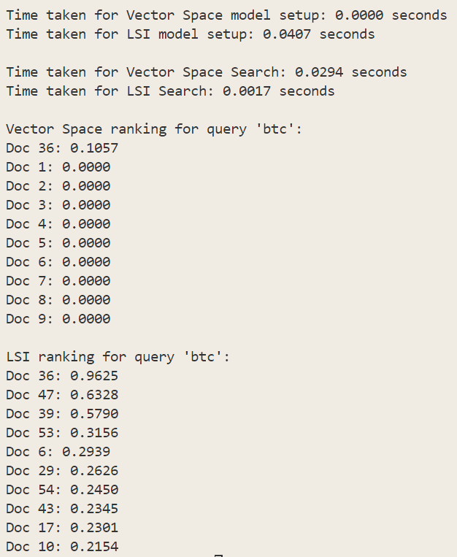
I intentionally added two documents about bitcoin but one without btc, which is an abbreviated form of bitcoin to check whether VSM could handle abbreviations. As resulted above, document #47 should’ve been included in the output since it contains the word “bitcoin” but VSM’s result does not show it. LSI correctly handles both document #36 and #47.

Query : “air in galaxy”
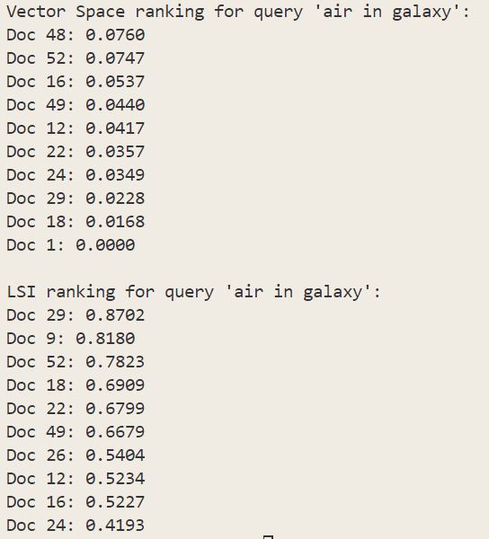
VSM precision : 4/5, however, failed for the top result
LSI precision : 5/5, word senses aligning across documents
The LSI correctly handles the sense the word “air” conveys from the query above. However, VSM produced wrong result with its #1 output containing Macbook air instead of air in galaxy, failing to grasp the true meaning.

- Time analysis :
The model setup time for VSM excelled LSI since LSI contains large amount of matrix computation including building tf-idf while VSM simply computes the tf-idf matrix.
The searching time for LSI excelled VSM since the size of dimensions was smaller, since it was collapsed to smaller dimensions, leaving top k important dimensions. Also LSI uses precomputed matrix ready for queries, while VSM simply refers to the sparse matrix to give ranking.

K value test :
K=10 :
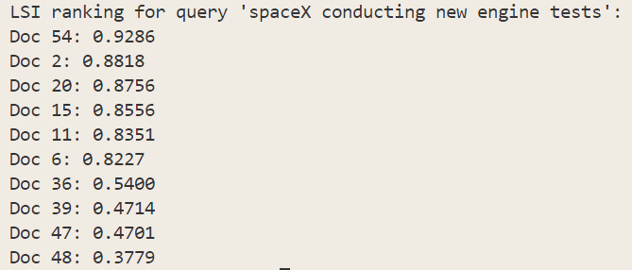
K=20 :
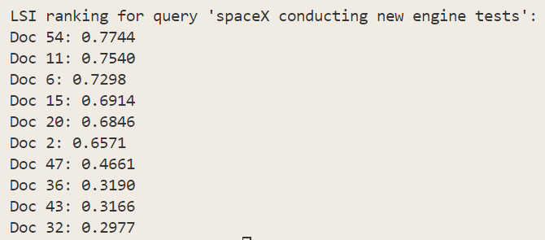
K=30 :
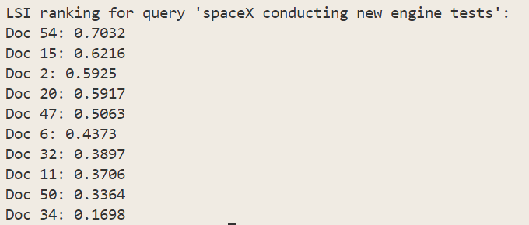
K=40 :
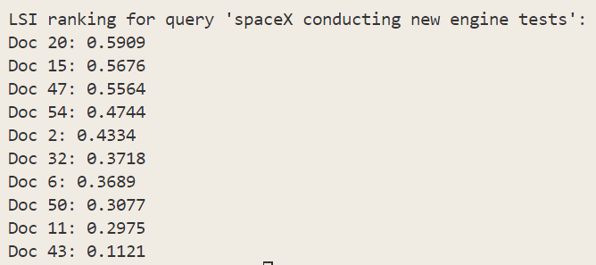
K=50:
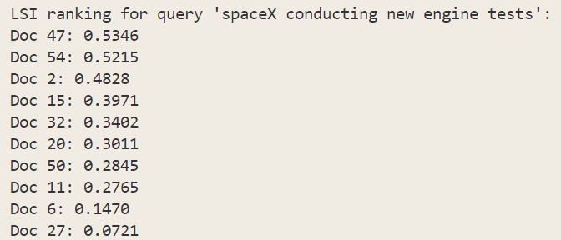

After conducting ranking with 5 different k values, I found k=30 gave me the most satisfactory results. Because k is the number of dimensions the matrix collapses into, it had both benefits and side effects when increasing or decreasing. Currently, the metric is in hands of mine, I manually evaluated precision to find the best k among the five. Regarding that the number of documents that I have is only 55, I could not use values greater than that.

5.2 Qualitative result & summary
- LSI’s results seemed to be organized around a certain topic
- VSM’s top results were mostly fine, but wrong results were far off topic
- LSI could handle variants of a word, synonyms and polysemy
- LSI could also handle abbreviations.
- VSM did not lay hold of any relationships between words

6. Conclusion & Future Work
This project set out to demonstrate the difference between LSI and non-LSI. By collapsing 5000 terms into 30 latent topics, I could lift precision@5 from 55 to 76. I could also rescue synonym-rich domain-specific documents that the baseline missed. Grasping the pure sense according to context was possible, thanks to term-to-term co-occurrence matrix, pushing the context-irrelevant documents out. The benefit all came from a single SVD step where the stiff surface of tf-idf got rotated into latent “concept” space and the noises got discarded.
For further improvement, I suggest randomized or incremental SVD can be the following update to the current project. Also, comparing with other latent methods could be a way to gain insight into information retrieval. Speaking of the size of the document, I could collect more documents for generalization, along with domain expansion.

